Practical 9
Aim
To implement localStorage and sessionStorage in JavaScript to save user preferences such as theme settings.
Software Required
- Visual Studio Code (or any code editor)
- Web browser with Developer Tools (Google Chrome / Microsoft Edge / Mozilla Firefox)
- Live Server extension (or any local server) for VS Code
- Basic knowledge of HTML, CSS and JavaScript
Theory
The Web Storage API allows a web page to store data as key–value pairs inside the user's browser, without sending it to a server. Compared with cookies (about 4 KB, attached to every HTTP request), Web Storage offers far more space — roughly 5 MB per origin — and is read only by client-side scripts. Data is limited to the same origin (protocol, domain and port) and is always stored as strings, so objects must be converted with JSON.stringify() before saving and JSON.parse() after reading. The API provides two mechanisms with an identical interface: localStorage and sessionStorage.
localStorage keeps data with no expiry date. It survives page reloads, closing the tab, and restarting the browser, and it is shared by every tab opened on the same origin. This makes it the natural choice for user preferences such as theme, accent colour, language, or font size, which should be remembered on every future visit. sessionStorage, in contrast, is scoped to a single browser tab: it survives a page reload but is wiped as soon as the tab or window is closed, and a new tab always starts with empty sessionStorage. It suits temporary data such as unsent form drafts or a per-visit counter.
Feature | localStorage | sessionStorage
Lifetime | Persists until deleted by the user or code | Cleared when the tab/window is closed
Scope | Shared by all tabs of the same origin | Limited to a single tab
Survives page reload | Yes | Yes
Capacity | About 5 MB per origin | About 5 MB per origin
Typical use | Theme, language, saved settings | Temporary drafts, per-visit counters

Both objects expose the same methods: setItem(key, value) stores or updates a value; getItem(key) returns the value, or null if the key does not exist; removeItem(key) deletes a single key; clear() empties the storage; key(n) returns the name of the nth key; and the length property gives the number of stored items.
To save a theme preference, the page writes the user's choice to localStorage inside the click handler, and on every page load reads it back and applies it — typically by setting a data-theme attribute on the root element so that CSS variables change the colours of the whole page. Reading the value in a small script before the page is painted avoids a visible flash of the wrong theme. Because storage can be unavailable (private browsing, blocked cookies) or full, reads and writes should be wrapped in try/catch. Finally, a ‘storage’ event is fired in other open tabs of the same origin whenever localStorage changes, which lets those tabs update themselves instantly.
Implementation Overview
A single-page application named Preference Studio was built. The ‘Your Preferences’ panel lets the user choose a theme (Light, Dark or Sand), an accent colour, a text size, and a display name; each choice is written to localStorage immediately and re-applied on every load. The ‘This Session’ panel uses sessionStorage to track the number of page loads in the current tab, the session start time, and a scratchpad note, alongside localStorage-based total visits and the previous visit time for comparison. A live Storage Inspector lists every key currently held in both storages, and Reset and Clear buttons demonstrate removeItem() on each.
Output
File Path - file:///D:/Symbiosis%20University/Sem%205/JavaScript/JavaScript%20VSCode/Practical%209/Case%20Study/index.html
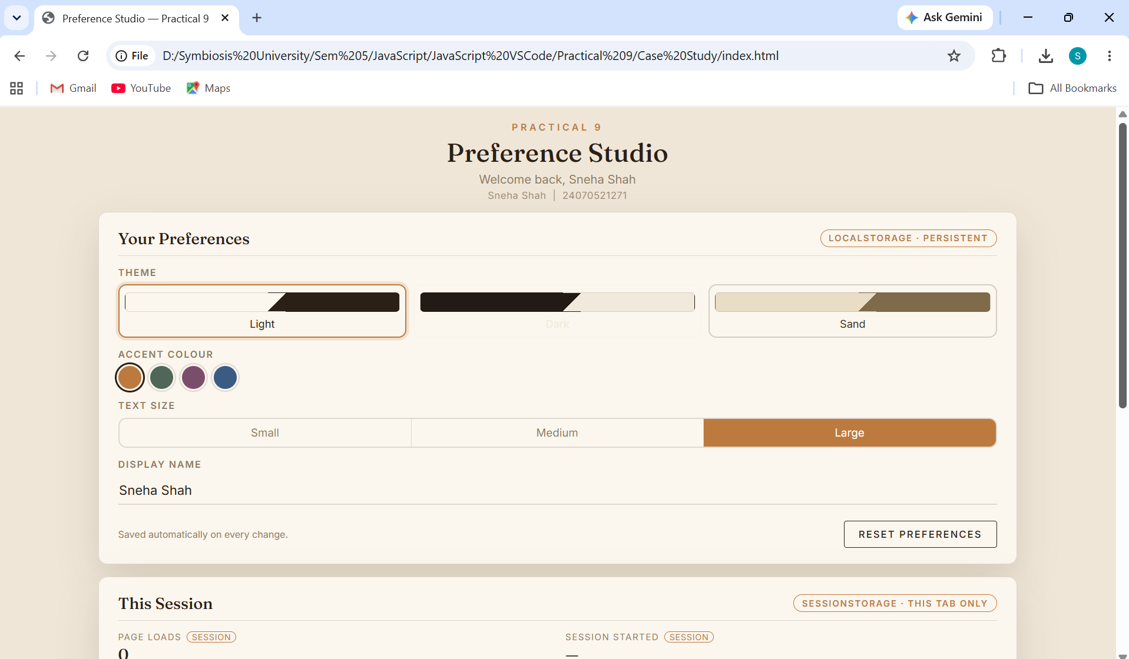
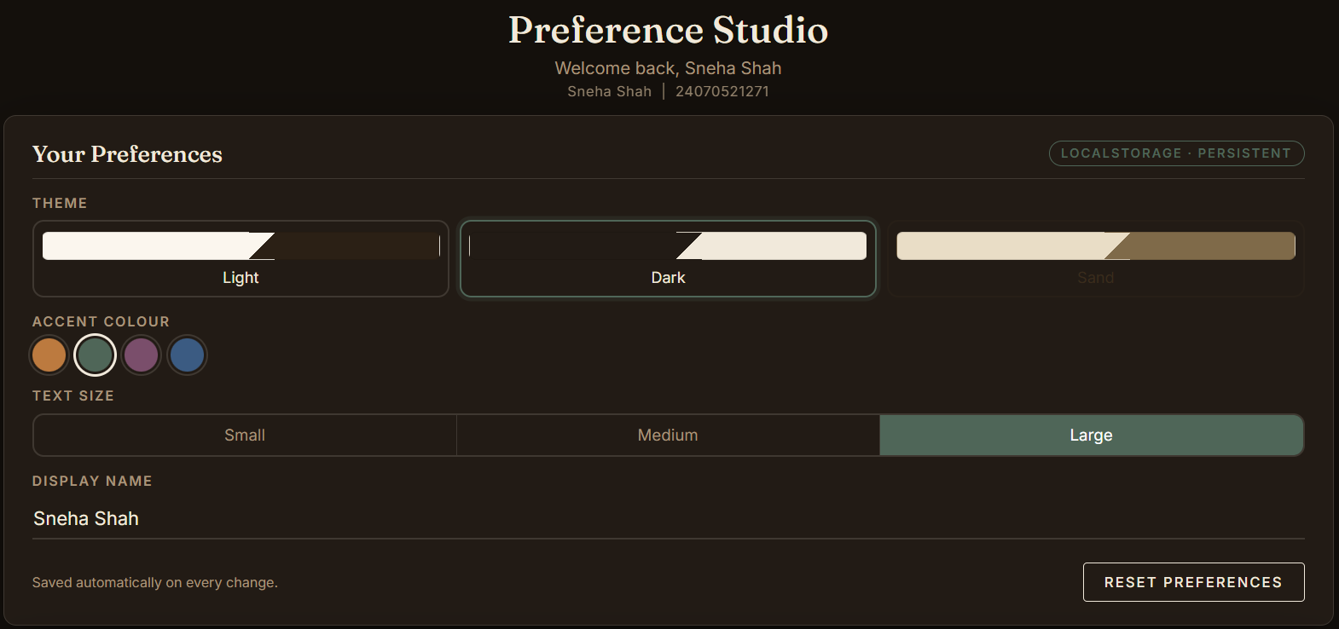
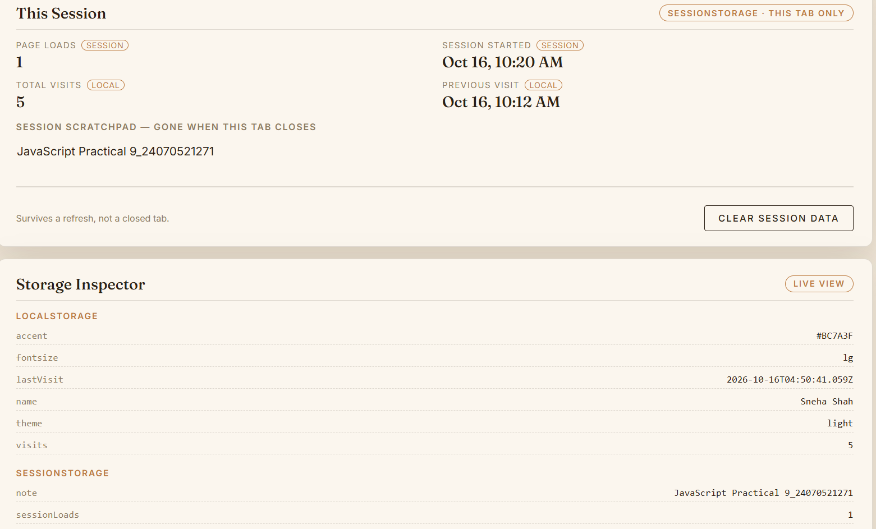

24070521271_SnehaShah
Result
The application was executed successfully. Changing the theme, accent colour, text size or display name updated the interface instantly and stored the choice under keys in localStorage; after refreshing the page and even after closing and reopening the browser, the same preferences were restored without any flash of the default theme. The sessionStorage values behaved differently: the page-load counter and scratchpad note survived a refresh but were cleared once the tab was closed, while the total visit count kept increasing across sessions. The Storage Inspector and the browser's Developer Tools confirmed the stored key–value pairs in each storage area.
Conclusion
Thus, localStorage and sessionStorage were studied and implemented to save user preferences. localStorage proved suitable for long-term settings such as theme choice, since it persists across browser restarts, whereas sessionStorage is better for temporary, tab-specific data. Together they allow a web application to remember user preferences and personalise the interface without any server-side storage.

